**ANDROID APPLICATION**

**SOCIAL INTERACTIVE APP**



**PATRIK IHNAT(260010),**

**PATRIK KUCERKA(260026),**

**ANDREW FARID NGWIRA(260008).**

**Supervisor: KASPER KNOP RASMUSSEN**

**VIA UNIVERSITY COLLEGE**

# Table of content

Table of content 2

List of figures and tables 2

Abstract 3

Introduction 3

Requirements 4

Functional Requirements 4

Non-Functional Requirements 4

Analysis 4

Use Case Description 5

Domain Model 6

Design 7

Implementation 8

Test 8

Test Specifications 8

Results and Discussion 8

Conclusions 9

Project future 9

Sources of information 9

Appendices 10

Appendix A Project Description 10

# List of figures and tables

Optional

# Abstract

In the age in which we live the power of mordent hand held devices like tablets and smartphones has grown tremendously. One of the areas that has its doors wide open is communication through the internet (social media). We have several social interactive applications that have skyrocketed over the few years and these include communication platforms like Facebook, twitter, Instagram, skype etc. All these applications are good but how then do you keep certain information private with people who would be able to relate to you whenever something is happening health wise, so this brings us to this very project.

The purposes of this project is to create a social networking environment for people suffering from the same sickness or illness to be able to share their stories as so that they can encourage, support and strengthen one another through messages and posts that are specifically related to them. This would remove all necessary information from people who are clueless of what people with the same illness are going through.

The application is built in Android Studio IDE and is implementing google firebase as a means to achieve remote access interaction among it’s users who can be anywhere in the world as long as they are connected to the internet. It also uses and Android Software Development Kit (SDK) which includes a variety of tools that help us develop mobile android applications.

Results to be displayed with the aid of snippets……………………………………………….

# Introduction

The project is based on a social interactive application that is purposely designed for people with certain diseases that provide a common ground for every kind on communication over this platform through posts and messages.

The android application will serve as a communication platform for people having mental illness or sickness where they can give each other moral support as well as interact with volunteers who would like to help them.

This project is intended to provide a social health care service through social media interactions. It would also provide quick and easy access for people suffering from the same disease to share information regarding the struggles they are currently facing. The application to be developed will be made available through the means of internet connection with will connect the users to google firebase which will enable users to be anywhere in the world and still be able to interact. This project is also implemented with the aim of educating the users of each other’s situations.

The project is aimed at providing an easy connection and post platform for people all over the world and the requirements for the development of this project are discussed in the next section.

# Requirements

The requirements of the project were developed based on a kind of application that could connect people in different parts of the world and enable communication as well as authentication.

## Functional Requirements

1. User should be able to connect to the database from different devices
2. User should be able to see the UI with all necessary information
3. User should be able to create profile
4. User should be able to make Posts
5. User should be able to see other posts
6. User should be able to display posts by category
7. User should be able to send email to whoever made a post
8. User should be able to send messages to other people
9. User should be able to receive messages
10. User should be able to edit profile
11. User should be able to login
12. User be able to log out

# Non-Functional Requirements

1. Application to be built in Android Studio IDE
2. System to be developed using the same system version for all programmers
3. Application to run on only Android devices

# Analysis

This chapter deals with the analytical process that happens right before the designing of the application system to be developed. Here we took into consideration what was required of this system, meaning from the requirements gathered how could we put them together to come up with an analysis that would enable us to develop a system that is satisfying to our consumers/stakeholders.

The system was to be build in android studio and to cater for android devices specifically. It had to be developed with a remote accessibility feature as well as authentication which is of great importance considering the amount of news about people identities being stolen. The system was to have a platform where users could make posts and be able to read and see other posts.

Use Case Modeling

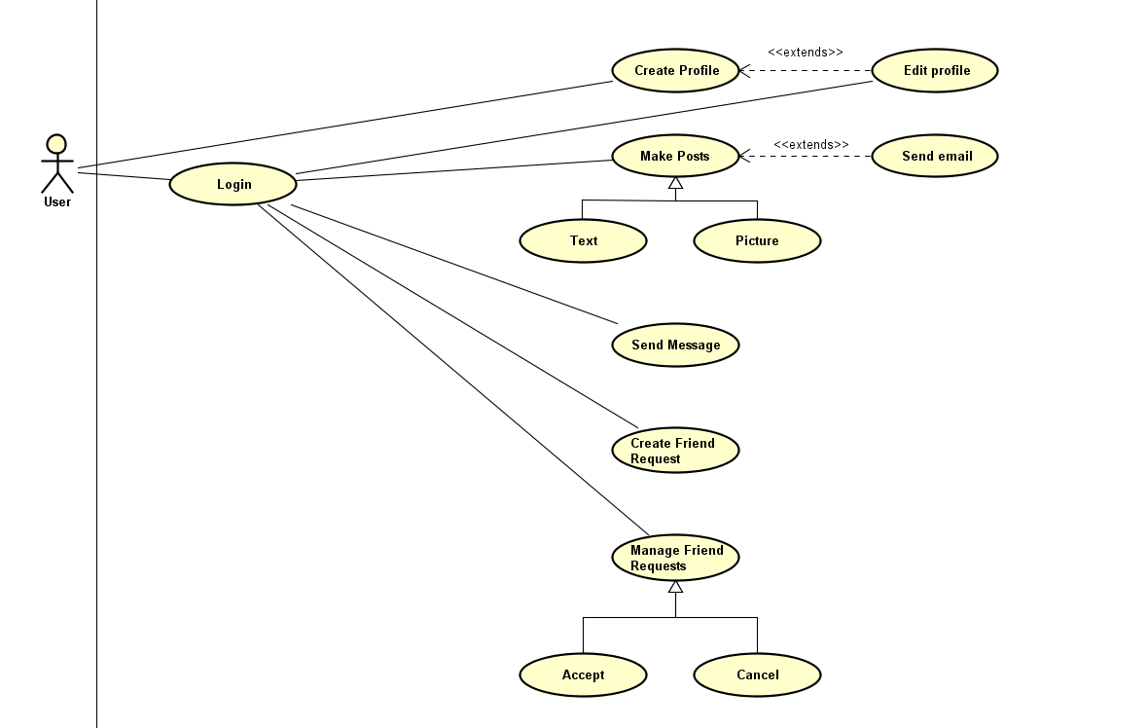

Figure 1: Use Case Diagram

Figure 1 illustrates some various scenarios that a user of this system would encounter upon running the system. The expected outcomes are also made visible in the use case diagram.

## Use Case Description

|  |  |
| --- | --- |
| Use case | Login |
| Summary | Should be able to log into the application. |
| Actor | User |
| Precondition | User must have a profile in the system. |
| Postcondition | User must be logged in. |
| Base sequence | 1. User opens application 2. User selects a button between login or create profile 3. If create profile then profile page opens and is created. 4. If login then enters username and password. |
| Exception sequence | System will ask user to enter right credentials. |

Table1: Use case description of login use case

Table 1 shows the steps taken for the user to log into the application. This is the primarily step that users will encounter.

## Domain Model

This domain model incorporates both the behavior and the data that is being manipulated.

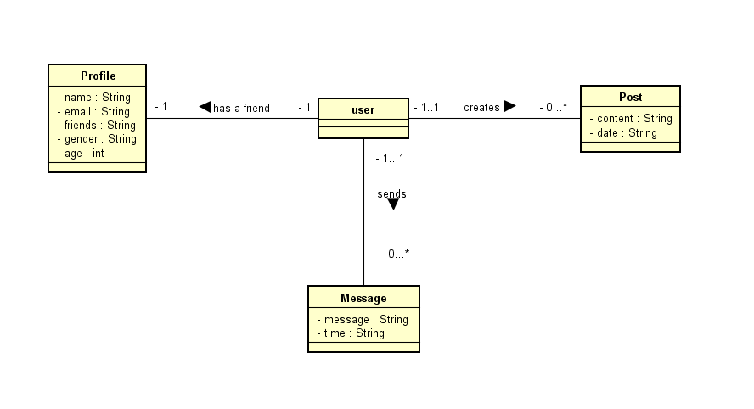

Figure 2: Domain Model

Domain model illustrates that a user has only one profile and can create as many posts as they want and send messages. These posts and messages have or belong to a single user.

# Design

In this chapter we discuss how the system was to be designed according to the analytical phase the was given to cover for all the needs expected to be met by the system being developed.

The design of the application has been done in such a way that it was built on a Model View ViewModel architecture (MVVM). The reason why we chose this architecture is to have a user interface that will not lose information that the user has whenever they choice to rotate the phone because all the information will be stored in the ViewModel that acts as a cache for the UI.

(code pic)

Google firebase database has been used to provide wide wide data accessibility that the users will need thereby covering the remoteness of the application and it also enables our app to have user authentication which enables only the users to have access to the database.

(code pic)

The application was to have Posts that would be held in a recyclerview which would also need an adapter implementation to create and add content to the views.

(code pic)

# Implementation

The purpose of the implementation section is to explain interesting code snippets. An idea is to explain the complete path through your system from UI to database etc.

Remember that your implementation must be consistent with your design (Larman 2004, chap.20).

Which standard libraries are used? How are design patterns implemented, etc.

Hint: Implement your code in a testable manner.

# Test

Tests on the project have been conducted using black box testing which focuses on whether the functionality listed as requirements have been completed without testing particular code.

## Test Specifications

|  |  |  |
| --- | --- | --- |
| Requirement | Test | Result |
|  |  |  |
|  |  |  |

# Results and Discussion

The purpose of the results and discussion section is to present the outcome and achieved results of the project.

# Conclusions

The purpose of the conclusion section is to compile the results from each section in the report. What is the conclusion? Did the project fulfil the requirements? Etc.

You can only comment on report contents, no new topics or content can be introduced in this section.

# Project future

Reflect on your project from a technical viewpoint and describe what you would change if you could.

Suggest how the project could be improved or made ready for production. Discuss scalability, suggest possible spin offs, what is needed, missing, etc.?

# Sources of information

**Note: Use the standard reference method: Harvard Anglia. A very good reference tool is Mendeley** (Mendeley.com 2016), **ask VIA Library if you need help.**

Banger, D., 2014. A Basic Non-Functional Requirements Checklist « Thoughts from the Systems front line.... Available at: https://dalbanger.wordpress.com/2014/01/08/a-

basic-non-functional-requirements-checklist/ [Accessed January 31, 2017].

Business Analyst Learnings, 2013. MoSCoW : Requirements Prioritization Technique

— Business Analyst Learnings. , pp.1–5. Available at: https://businessanalystlearnings.com/ba-techniques/2013/3/5/moscow-technique-requirements-prioritization [Accessed January 31, 2017].

Dawson, C.W., 2009. *Projects in Computing and Information Systems*, Available at: http://www.sentimentaltoday.net/National_Academy_Press/0321263553.Addison. Wesley.Publishing.Company.Projects.in.Computing.and.Information.Systems.A.St udents.Guide.Jun.2005.pdf.

Gamma, E. et al., 2002. *Design Patterns* *–* *Elements of Reusable Object-Oriented*

*Software*, Available at:

http://books.google.com/books?id=JPOaP7cyk6wC&pg=PA78&dq=intitle:Design+

Patterns+Elements+of+Reusable+Object+Oriented+Software&hl=&cd=3&source=

gbs_api%5Cnpapers2://publication/uuid/944613AA-7124-44A4-B86F-

C7B2123344F3.

IEEE Computer Society, 2008. *IEEE Std 829-2008, IEEE Standard for Software and* *System Test Documentation*,

Larman, C., 2004. *Applying UML and Patterns: An Introduction to Object-Oriented* *Analysis and Design and Iterative Development*,

Mendeley.com, 2016. Homepage | Mendeley. Available at: https://www.mendeley.com/ [Accessed February 2, 2017].

YourCoach, S.M.A.R.T. goal setting | SMART | Coaching tools | YourCoach Gent. Available at: http://www.yourcoach.be/en/coaching-tools/smart-goal-setting.php [Accessed August 19, 2017].

# Appendices

The purpose of your appendices is to provide extra information to the expert reader.

List the appendices in order of mention.

Examples of appendices

* Project Description
* User Guide
* Source code – source documentation
* Diagrams
* Data sheets
* Etc.

# Appendix A Project Description

Insert the original Project Description here